الغلاف الخارجى للبحث

|  |  |  |  |  |  |  |  |  |  |
| --- | --- | --- | --- | --- | --- | --- | --- | --- | --- |
| أولاً: البيانات الخاصة بالطالب | | | | | | | | | |
| **الفرقة الدراسية** |  | | | **التخصص** | | |  | | |
| **اسم القسم** |  | | | | | | | | |
| **اسم المقرر** |  | | | | | | | | |
| **استاذ المقرر** |  | | | | | | | | |
| ثانياً: البيانات الخاصة بالبحث | | | | | | | | | |
| **عنوان البحث** |  | | | | | | | | |
| **طبيعة المشاركة** | **بحث فردى** | | | | | **بحث جماعى** | | | |
| **ارسال البحث** | **بواسطة البريد الالكتروني** | | | | | | | | |
| **اسماء الطلاب المشاركين فى البحث**  **(يكتب الاسم رباعيا)** | **م** | **الاسم رباعى** | | | | **رقم الجلوس** | | | **الرقم القومى** |
| **1** |  | | | |  | | |  |
| **2** |  | | | |  | | |  |
| **3** |  | | | |  | | |  |
| **4** |  | | | |  | | |  |
| **5** |  | | | |  | | |  |
| **تاريخ الإرسال** | **/ 6 / 2020** | | | | | | | | |
| ثالثاً: البيانات الخاصة بالكونترول | | | | | | | | | |
| **النتيجة** | | | **ناجح** | | **راسب** | | | | |
| **أعضاء لجنة تقييم البحث** | **الاسماء** | | | | | | | **التوقيع** | |
| **1** |  | | | | | |  | |
| **2** |  | | | | | |  | |
| **3** |  | | | | | |  | |

|  |  |
| --- | --- |
| **فى حالة عدم قبول البحث يرجى ذكر الأسباب** | * **..............................................................................................................................................** * **..............................................................................................................................................** * **..............................................................................................................................................** * **.............................................................................................................................................** |

Use Case Diagram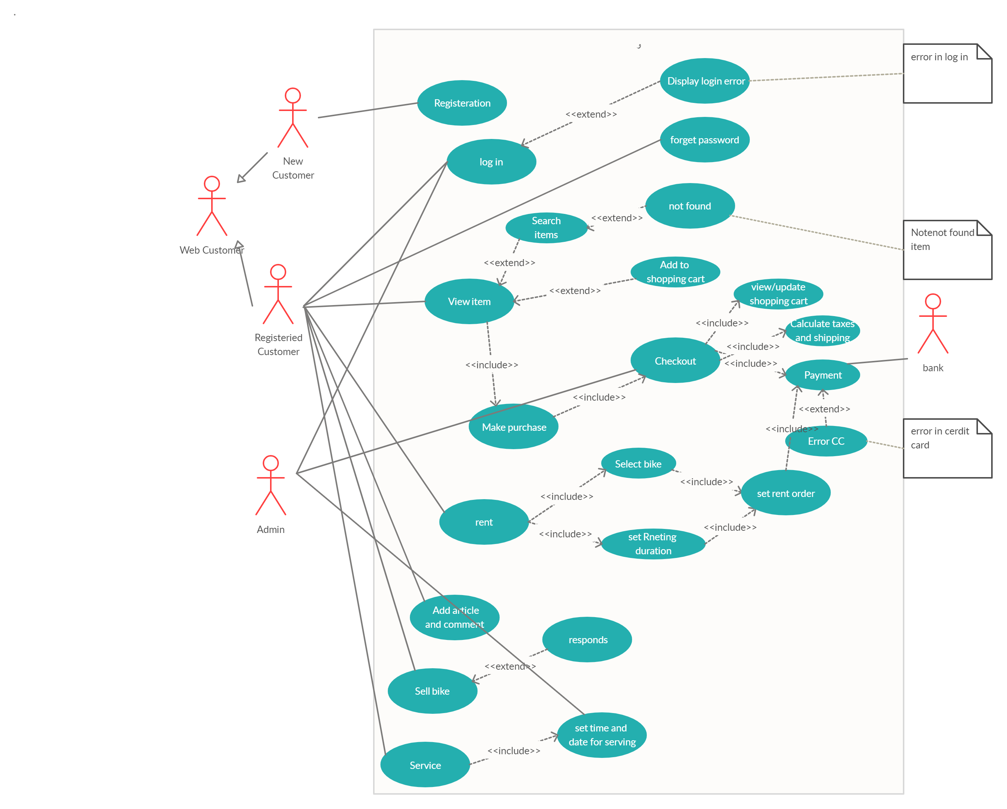

**Detailed Use Case Diagram**

UC1

|  |  |  |  |  |
| --- | --- | --- | --- | --- |
| Identifier and name | | | | UC1 Registration |
| Initiator | | New customer | | |
| Goal | | Registrants to system | | |
| Precondition | | None | | |
| Postcondition | | Unregistered customer become registered customer | | |
| Main success Scenario | | |  | |
| 1 | New customer inserts data   1. user name 2. first name 3. last name 4. phone number 5. password 6. confirm password 7. address 8. z-code   9-CC number | | | |
| 2 | System accept data | | | |
| 3 | User Registrated | | | |
| alternative |  | | | |
| 4 | System check data | | | |
| 5 | Data not valid | | | |
| 6 | Registration failed | | | |

Uc2

|  |  |  |  |  |
| --- | --- | --- | --- | --- |
| Identifier and name | | | | UC2 Log in |
| Initiator | | registered customer, admin | | |
| Goal | | Log in to the system | | |
| Precondition | | User have to has a valid account | | |
| Postcondition | | The system display homepage | | |
| Main success Scenario | | |  | | |
| 1 | registered customer , admin enters user name | | | | |
| 2 | registered customer, admin enter password | | | | |
| 3 | System verify user name and password | | | | |
| 4 | customer logged in | | | | |
| extension |  | | | | |
| 3.1 | User name or password is wrong | | | | |
| 3.1a | Error message rise up | | | | |
| 3.2 | Customer re enter user name and password | | | | |

Uc3

|  |  |  |  |  |
| --- | --- | --- | --- | --- |
| Identifier and name | | | | UC3 View item |
| Initiator | | Registered customer | | |
| Goal | | See item in store like bike, bike part | | |
| Precondition | | None | | |
| Postcondition | | Item viewed | | |
| Main success Scenario | | |  | | |
| 1 | Registered customer wants to view bike list | | | | |
| 2 | Bike list viewed | | | | |
| 3 | Registered customer wants to view bike part list | | | | |
| 4 | Bike parts list viewed | | | | |

Uc4

|  |  |  |  |  |
| --- | --- | --- | --- | --- |
| Identifier and name | | | | UC4 search |
| Initiator | | Registered customer | | |
| Goal | | Search for specific item | | |
| Precondition | | Customer on web site | | |
| Postcondition | | Reach to his search | | |
| Main success Scenario | | |  | | |
| 1 | Customer click search button | | | | |
| 2 | Customer enter name for his search | | | | |
| 3 | System looks up for his search | | | | |
| 4 | Product found | | | | |
| alternative |  | | | | |
| 5 | Customer refines search result by added more specific | | | | |
| 6 | Step 2 and 3 re-executed | | | | |
| Extension |  | | | | |
| 3.1 | System don’t find product | | | | |
| 3.1a | Not found rise a message product not found | | | | |

|  |  |  |  |  |
| --- | --- | --- | --- | --- |
| Identifier and name | | | | UC5 Add to shopping cart |
| Initiator | | Registered customer | | |
| Goal | | Add item to shopping cart | | |
| Precondition | | Item must be searched or viewed | | |
| Postcondition | | Added to cart | | |
| Main success Scenario | | |  | | |
| 1 | customer search for item or view it | | | | |
| 2 | System found item | | | | |
| 3 | System view item | | | | |
| 4 | Customer add item to shopping cart | | | | |
| Unsuccessful  Scenario |  | | | | |
| 5 | System doesn’t find item | | | | |
| 6 | System refines specific search | | | | |
| 7 | Re-enter name again | | | | |

|  |  |  |  |  |
| --- | --- | --- | --- | --- |
| Identifier and name | | | | UC6 Make purchase |
| Initiator | | Registered customer | | |
| Goal | | Customer want to make purchase | | |
| Precondition | | 1. Registered customer 2. There is item in shopping cart | | |
| Postcondition | | Registered customer will go to Checkout | | |
| Main success Scenario | | |  | | |
| 1 | Registered customer added item to cart successful | | | | |
| 2 | Registered customer asked for purchase | | | | |
| 3 | System convert him to checkout | | | | |
| Unsuccessful  Scenario |  | | | | |
| 4 | No item in cart | | | | |
| 5 | Purchase failed | | | | |

|  |  |  |
| --- | --- | --- |
| Identifier and name | | UC7 forget Password |
| Initiator | Registered customer, System | |
| Goal | Registered customer forgets his password | |
| Precondition | He must forget his password | |
| Postcondition | Password sent | |

|  |  |  |
| --- | --- | --- |
| Main success Scenario | |  |
| 1 | Registered customer forgets his password | |
| 2 | System verify user identity | |
| 3 | Registered customer confirm identity | |
| 4 | System send to Registered customer password | |
| Unsuccessful  Scenario |  | |
| 3.1 | Customer cannot confirm identity | |
| 3.2 | System send another verifying method | |
| 3.3 | Customer cannot confirm another method | |
| 3.4 | System will not send password | |

|  |  |  |
| --- | --- | --- |
| Identifier and name | | UC8 Check out |
| Initiator | Registered customer, admin, system, bank | |
| Goal | Registered customer wants to make check out for his purchase | |
| Precondition | Registered customer wants to make purchase | |
| Postcondition | 1-System will show to Registered customer his shopping cart  2-admin will set tax and shipping   1. Registered customer use payment for pay 2. Purchase will done | |

|  |  |  |
| --- | --- | --- |
| Main success Scenario | |  |
| 1 | Registered customer wants to make checkout | |
| 2 | System will show Registered customer his purchases | |
| 3 | Registered customer confirm his purchases | |
| 4 | Admin will set taxes and shipping | |
| 5 | Registered customer use payment method, bank valid it | |
| 6 | Purchases done | |
| Unsuccessful  Scenario |  | |
| 5.1 | Bank Payment method not valid | |
| 5.2 | Purchase dismissed | |

|  |  |  |
| --- | --- | --- |
| Identifier and name | | UC9 Calculate tax and shipping |
| Initiator | Admin | |
| Goal | Calculate shipping and taxes | |
| Precondition | Customer want to checkout | |
| Postcondition | Taxes and shipping will be Calculate | |

|  |  |  |
| --- | --- | --- |
| Main success Scenario | |  |
| 1 | Registered customer want to make checkout | |
| 2 | Admin set taxes and shipping money | |

|  |  |  |
| --- | --- | --- |
| Identifier and name | | UC10 View/update shopping cart |
| Initiator | System, Registered customer | |
| Goal | View/update shopping cart | |
| Precondition | Item added to shopping cart  Registered customer want to make purchase | |
| Postcondition | View or update shipping cart | |

|  |  |  |
| --- | --- | --- |
| Main success Scenario | |  |
| 1 | Registered customer add item to shopping cart | |
| 2 | Registered customer wants to make purchase | |
| 3 | System view shopping cart | |
| 4 | Registered customer want to add / delete item from shopping cart | |
| 5 | System update shopping cart | |

|  |  |  |
| --- | --- | --- |
| Identifier and name | | UC11 Payment |
| Initiator | Registered customer, bank | |
| Goal | Registered customer wants to pay for his purchase | |
| Precondition | Registered customer wants to checkout | |
| Postcondition | Payment done successfully | |

|  |  |  |
| --- | --- | --- |
| Main success Scenario | |  |
| 1 | Registered customer wants to Checkout | |
| 2 | Registered customer select online payment | |
| 3 | Registered customer enter CC number | |
| 4 | Registered customer enter CVV | |
| 5 | Registered customer enters EXP date | |
| 6 | Bank verify Data od CC | |
| 7 | Bank verified Data | |
| 8 | Payment Done | |
| Extension |  | |
| 7.1 | Bank said data not verified | |
| 7.3 | Payment does not complete | |

|  |  |  |
| --- | --- | --- |
| Identifier and name | | UC12 rent |
| Initiator | Registered customer, system | |
| Goal | Registered customer want to rent a bike | |
| Precondition | None | |
| Postcondition | Bike is rented | |

|  |  |  |
| --- | --- | --- |
| Main success Scenario | |  |
| 1 | System view bike for renting | |
| 2 | Registered customer select bike | |
| 3 | System request duraton | |
| 4 | Registered customer determine duration for renting | |
| 6 | Registered customer set order | |
| 7 | Registered customer pay for order | |
| 8 | System reserve bike for Registered customer | |

|  |  |  |
| --- | --- | --- |
| Identifier and name | | UC13 Set renting Duration |
| Initiator | Registered customer | |
| Goal | Determine renting duration | |
| Precondition | Registered customer wants to rent bike | |
| Postcondition | Registered customer set order | |

|  |  |  |
| --- | --- | --- |
| Main success Scenario | |  |
| 1 | Registered customer want to rent bike | |
| 2 | Registered customer select renting Duration | |

|  |  |  |
| --- | --- | --- |
| Identifier and name | | UC14 Set rent order |
| Initiator | Registered customer | |
| Goal | Set order to rent bike | |
| Precondition | Select bike and duration for renting must be selected | |
| Postcondition | Registered customer pay for his order | |

|  |  |  |
| --- | --- | --- |
| Main success Scenario | |  |
| 1 | Registered customer Select bike | |
| 2 | Registered customer Determine rent duration | |
| 3 | Registered customer Set order | |

|  |  |  |
| --- | --- | --- |
| Identifier and name | | UC15 Select bike |
| Initiator | Registered customer, System | |
| Goal | Registered customer select bike from renting bike list | |
| Precondition | Registered customer want to rent bike | |
| Postcondition | Bike selected | |

|  |  |  |
| --- | --- | --- |
| Main success Scenario | |  |
| 1 | Registered customer want to rent bike | |
| 2 | System offers renting bikes list | |
| 3 | Registered customer choose bike | |

|  |  |  |
| --- | --- | --- |
| Identifier and name | | UC16 Add article and comment |
| Initiator | Registered customer | |
| Goal | Add article and comment in blog section | |
| Precondition | None | |
| Postcondition | Added successfully | |

|  |  |  |
| --- | --- | --- |
| Main success Scenario | |  |
| 1 | Registered customer write article | |
| 2 | Registered customer posts the article | |
| 3 | Another Registered customer comment on the post | |

|  |  |  |
| --- | --- | --- |
| Identifier and name | | UC17 Sell bike |
| Initiator | Registered customer | |
| Goal | Want to sell his bike | |
| Precondition | None | |
| Postcondition | Registered customer post to sell his bike and receive response | |

|  |  |  |
| --- | --- | --- |
| Main success Scenario | |  |
| 1 | Registered customer but his bike photo to sell it | |
| 2 | Registered customer wait for responds | |

|  |  |  |
| --- | --- | --- |
| Identifier and name | | UC18 responds |
| Initiator | Registered customer | |
| Goal | Registered customer responds to buy bike from another Registered customer who post it for sold | |
| Precondition | None | |
| Postcondition | His responds is done | |

|  |  |  |
| --- | --- | --- |
| Main success Scenario | |  |
| 1 | Registered customer sent responds on another Registered customer | |
| 2 | Responds will be sent to the another Registered customer | |

|  |  |  |
| --- | --- | --- |
| Identifier and name | | UC19 Service |
| Initiator | Registered customer | |
| Goal | Registered customer request service | |
| Precondition | None | |
| Postcondition | Registered customer set data and time for serving | |

|  |  |  |
| --- | --- | --- |
| Main success Scenario | |  |
| 1 | Registered customer want to make service for his bike | |
| 2 | Registered customer set information about bike | |
| 3 | Registered customer set information about kind of service | |

|  |  |  |
| --- | --- | --- |
| Identifier and name | | UC20 Set time and date for serving |
| Initiator | Registered customer, admin | |
| Goal | Registered customer set data and time and admin confirm it | |
| Precondition | Request service | |
| Postcondition | Service is been scheduled | |

|  |  |  |
| --- | --- | --- |
| Main success Scenario | |  |
| 1 | Registered customer set time and date | |
| 2 | Admin receive date and time | |
| 3 | Admin schedule serving time | |
| 4 | Service scheduled | |

**Sequence diagram**

Registration UC 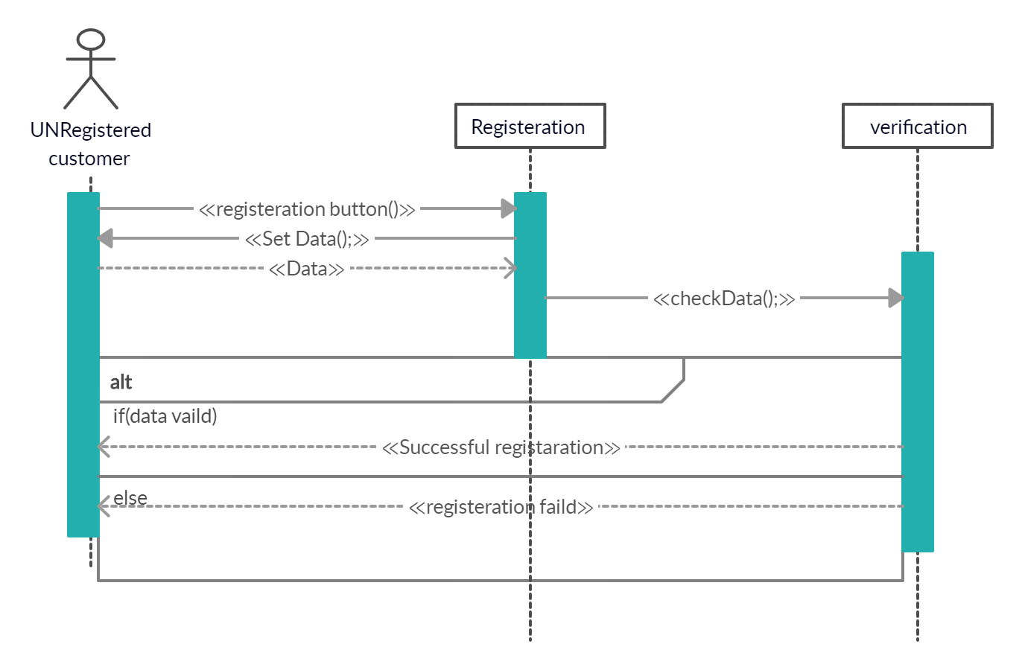

Login UC 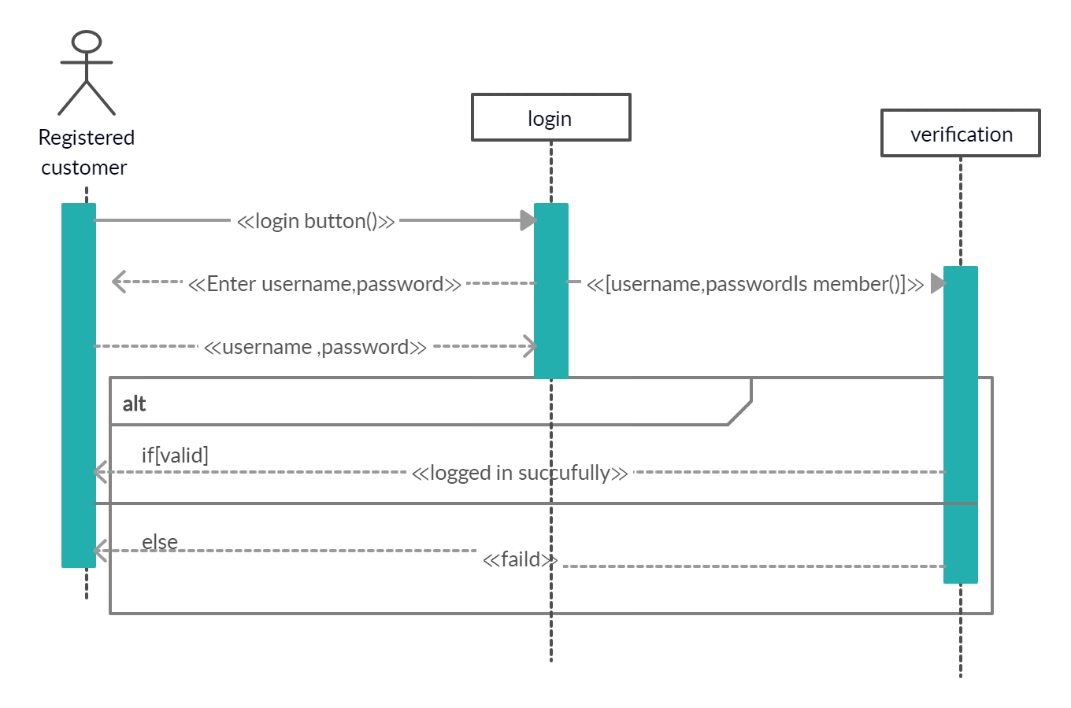

View item UC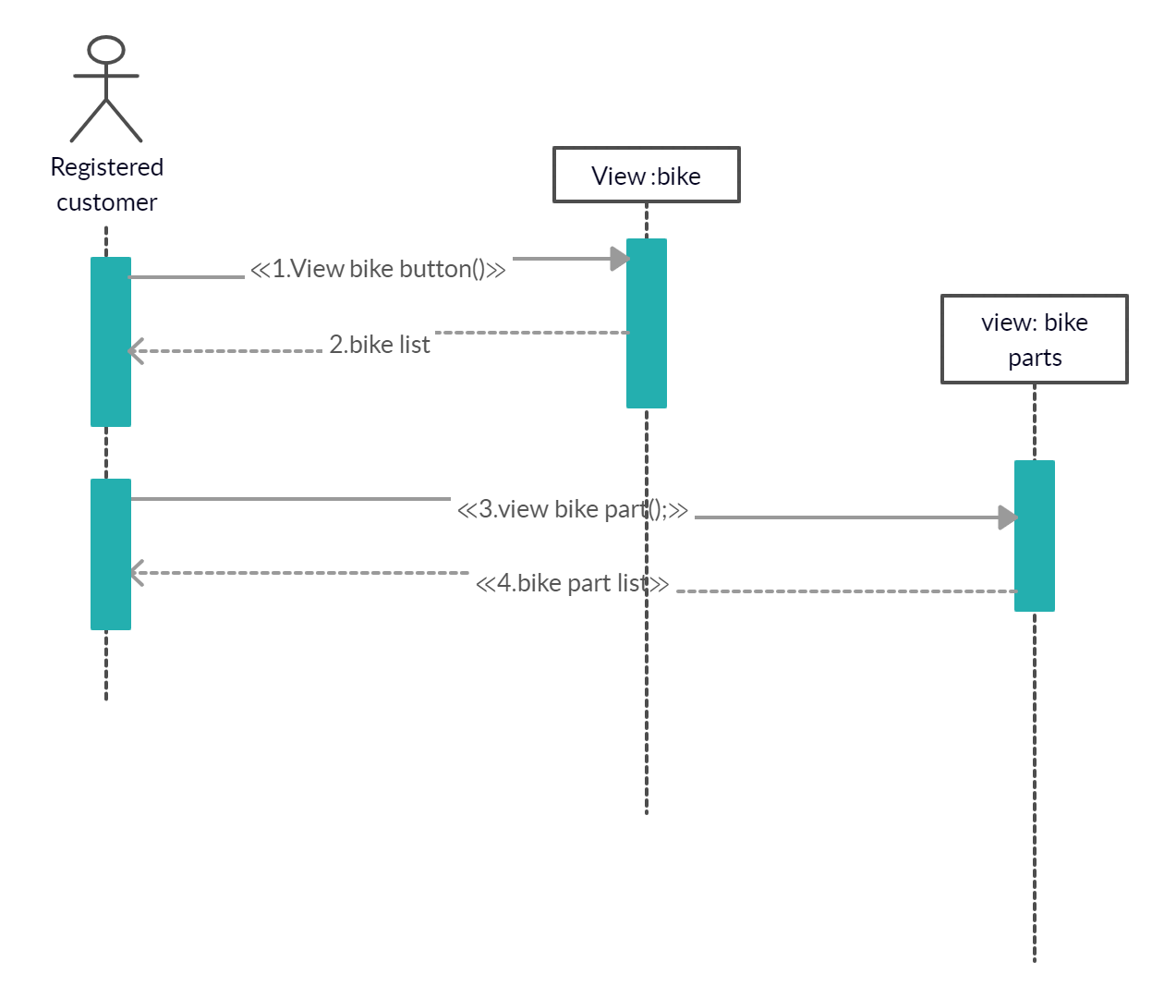

Search UC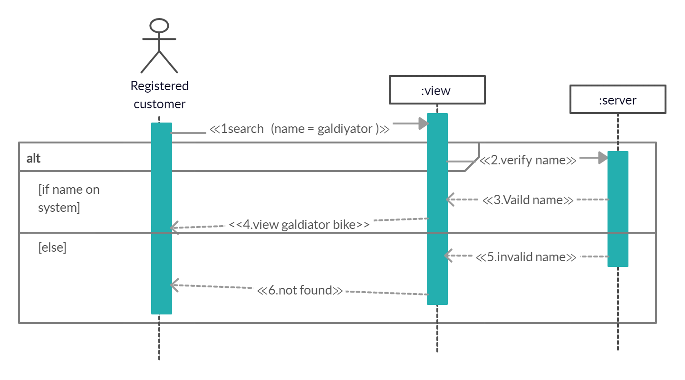

Add to shopping cart UC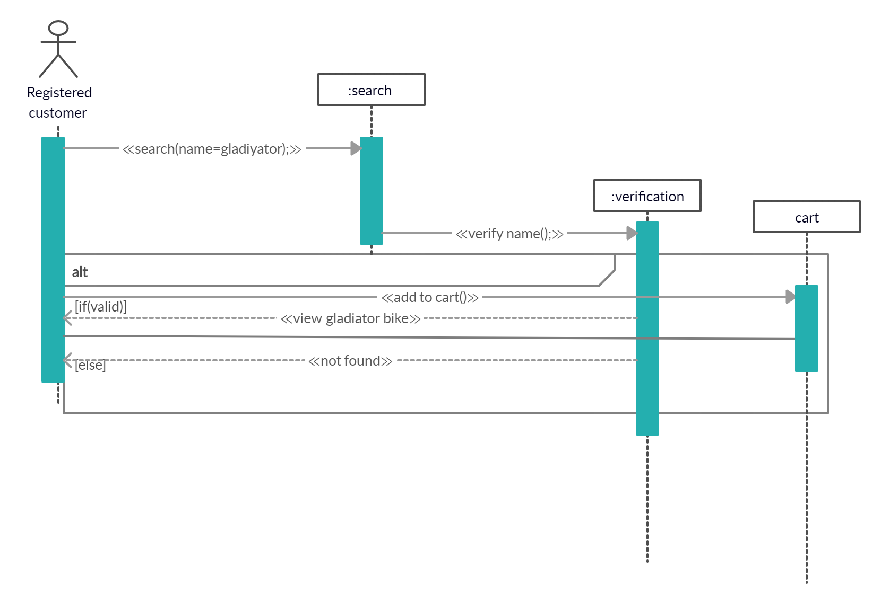

Make purchase UC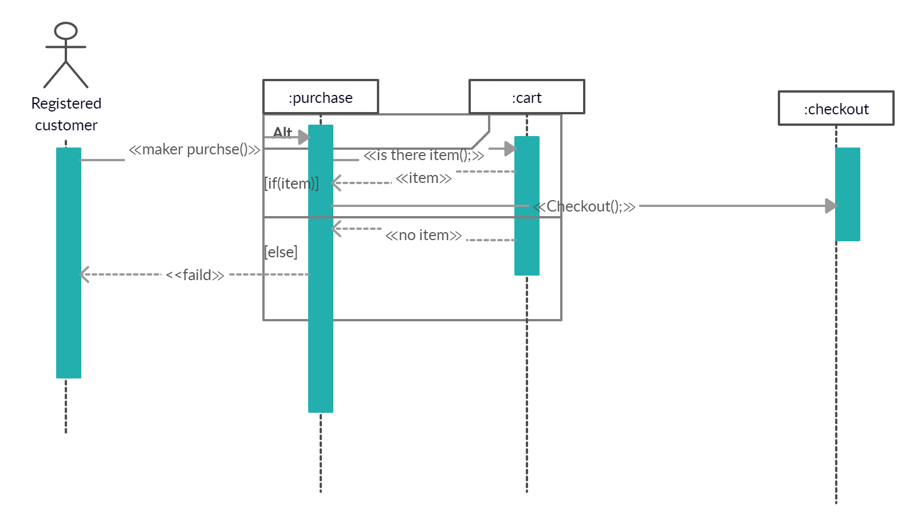

Forget password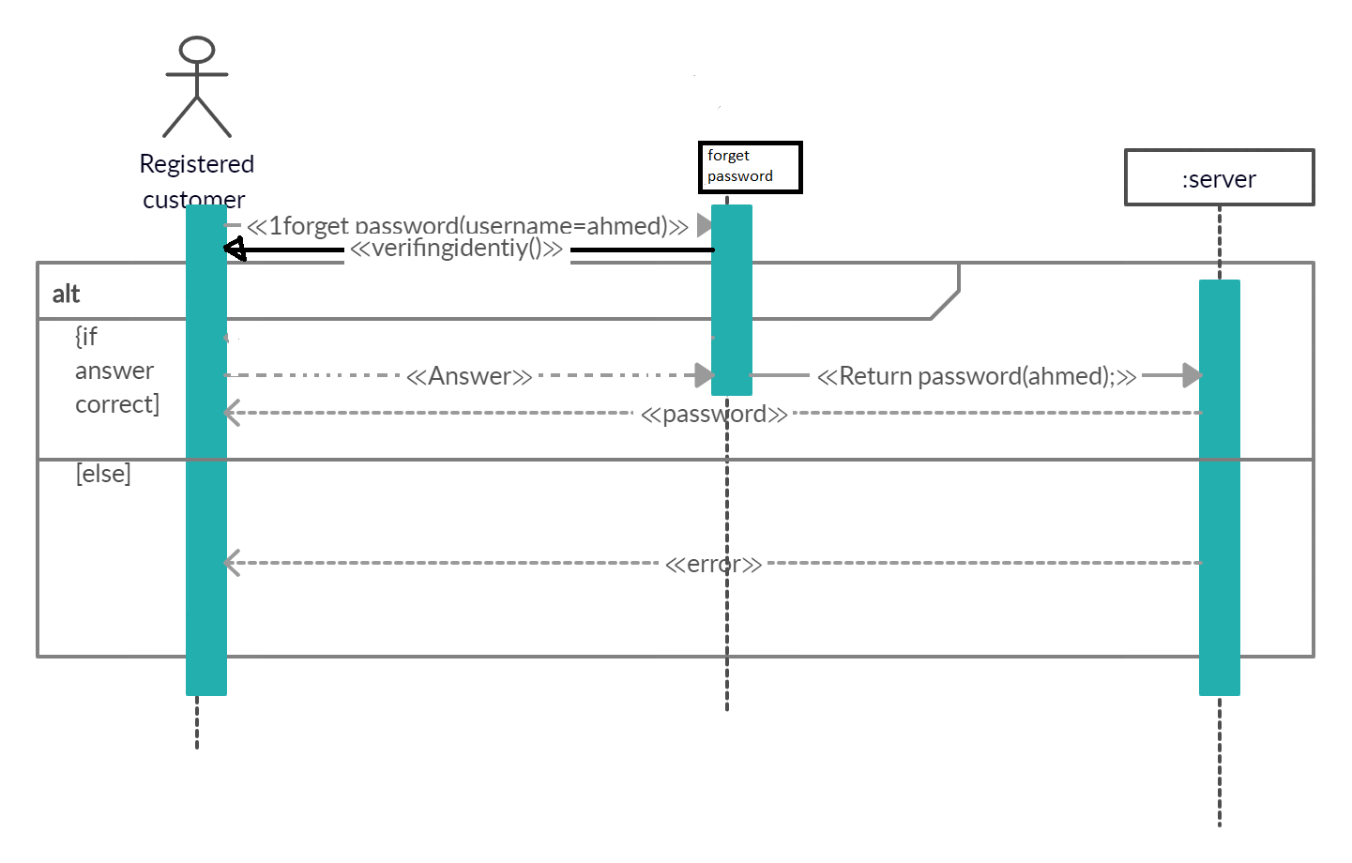

Checkout Uc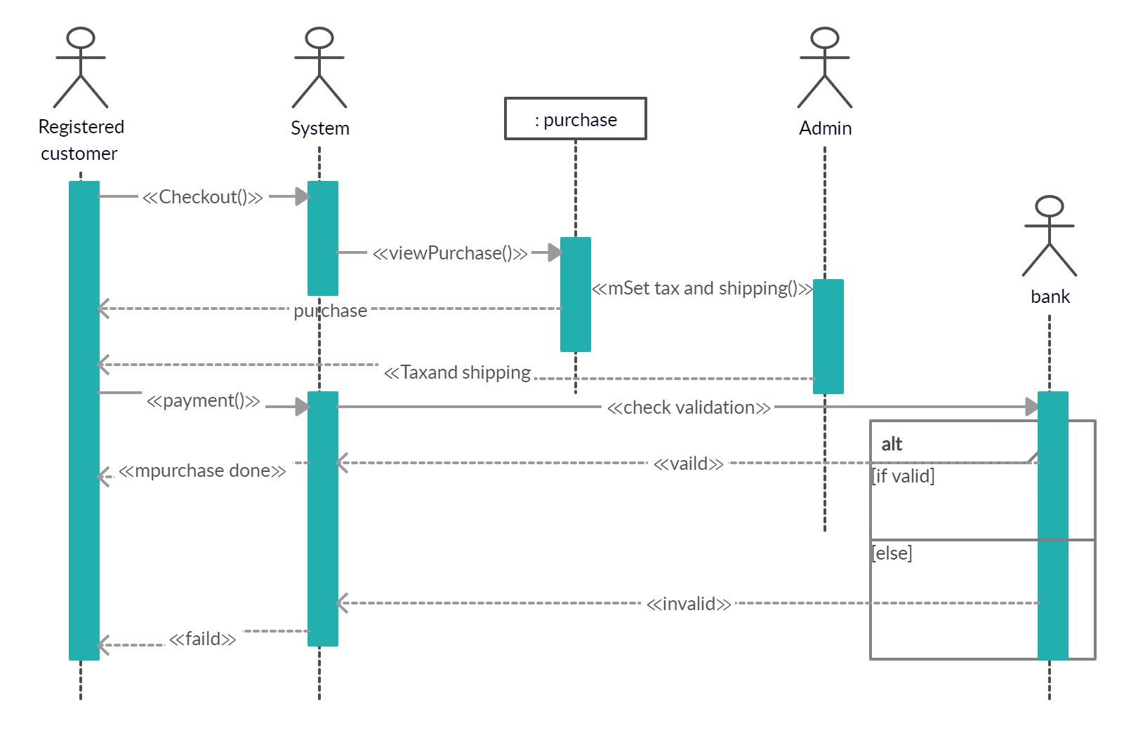

Calculate tax UC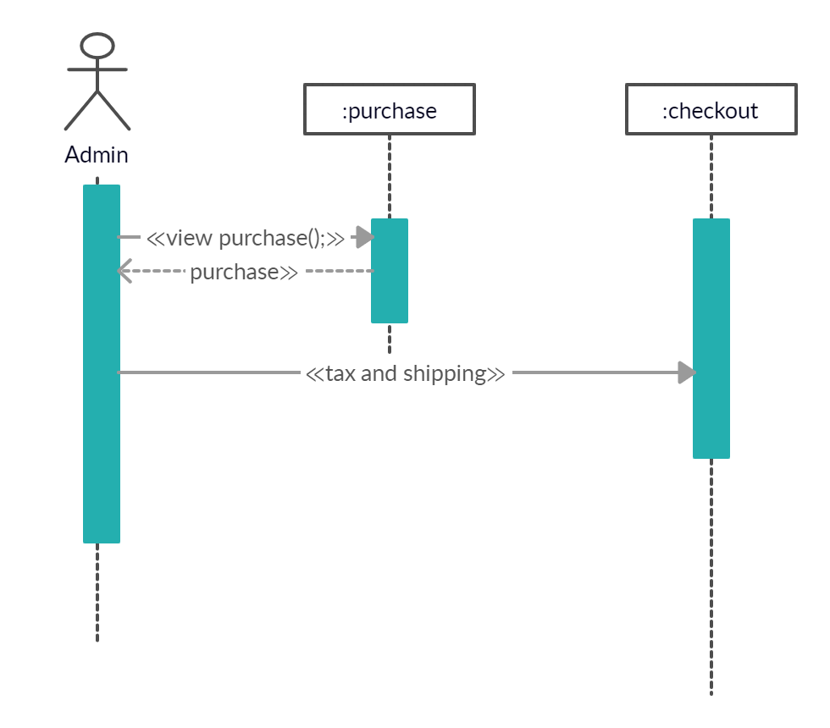

View/update shopping cart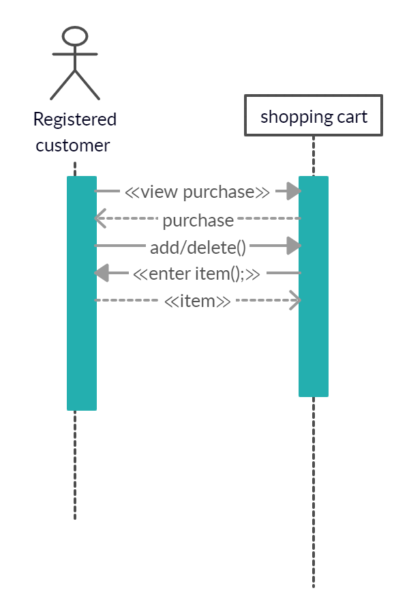

Payment 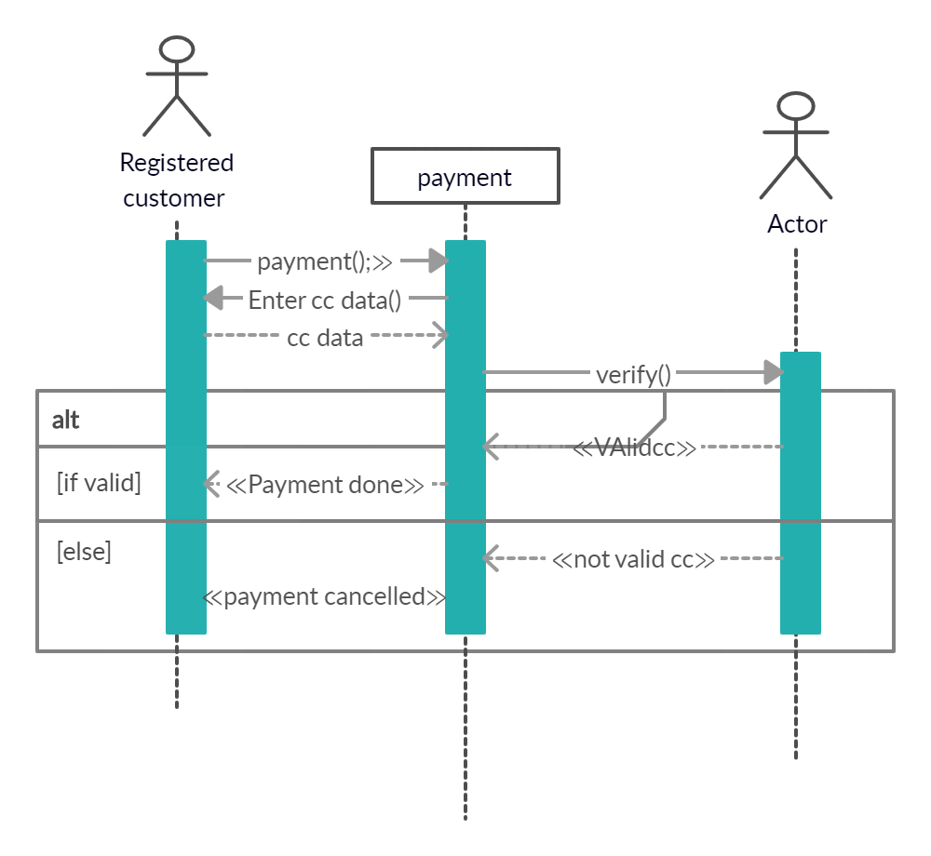

Rent uc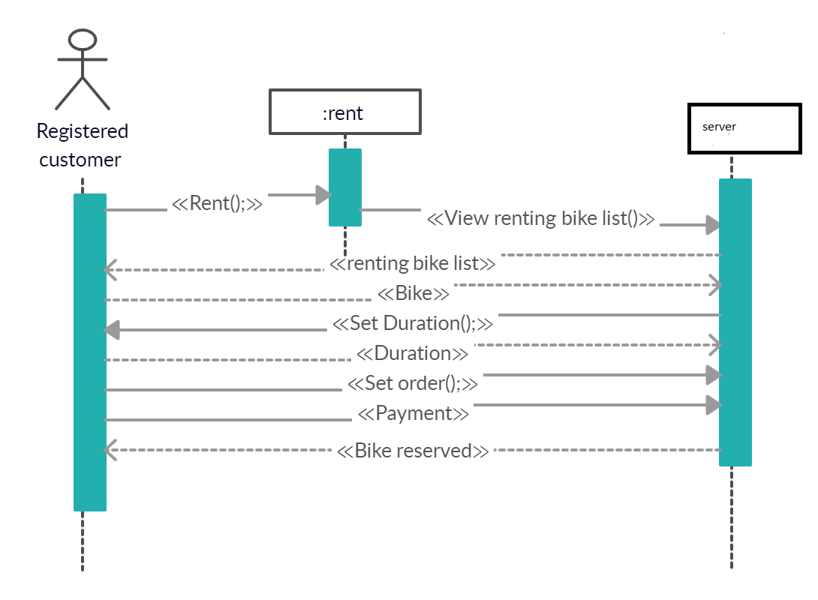

Select bike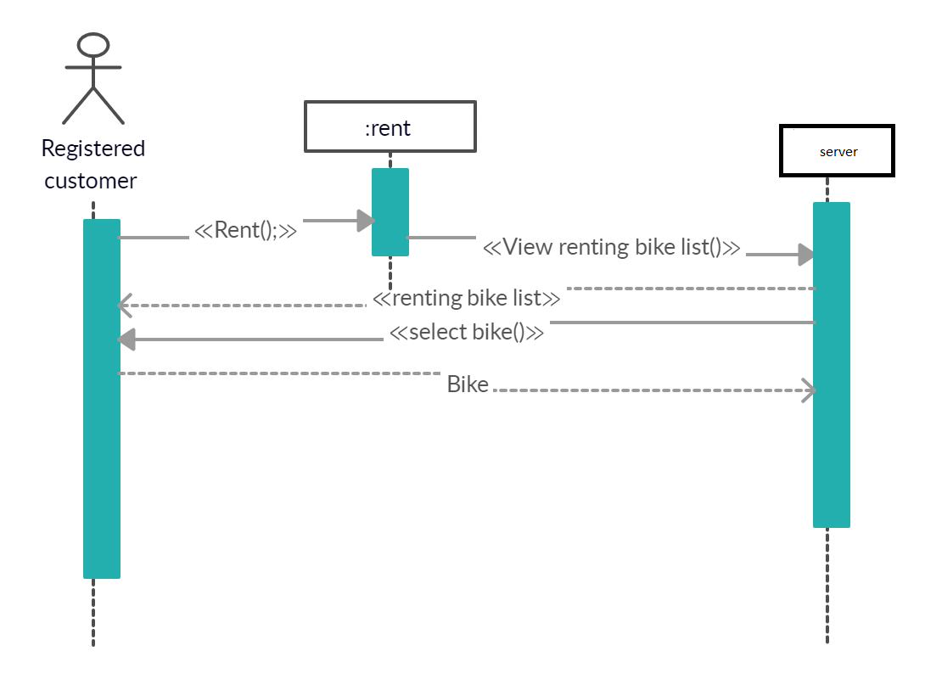

Add Article UC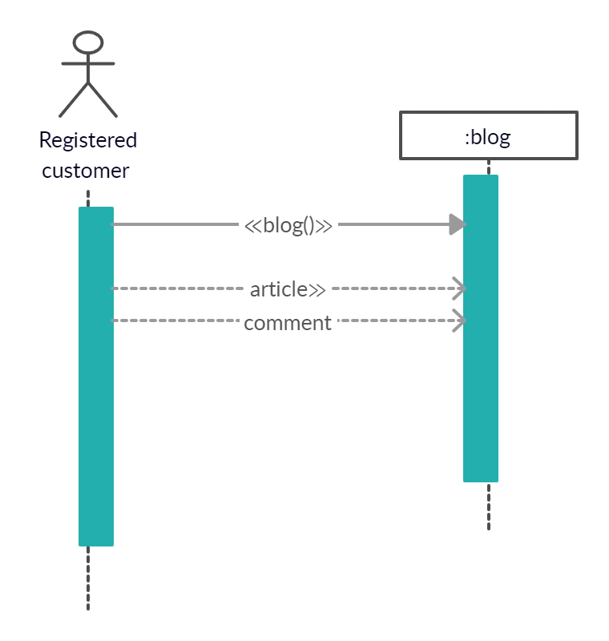

Responds UC 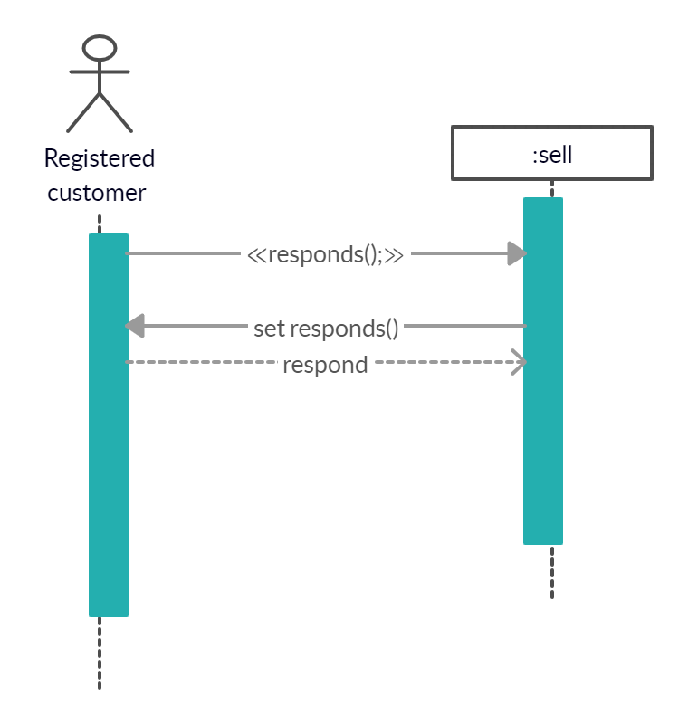

Sell UC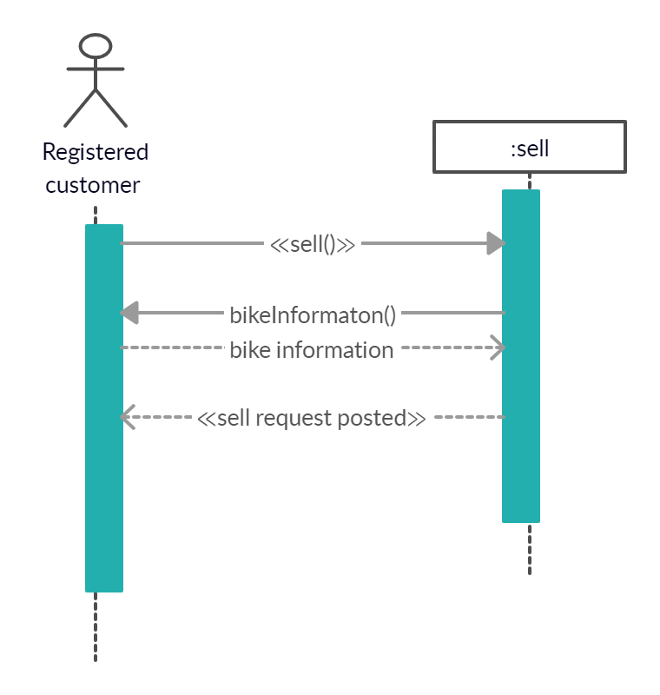

Service UC 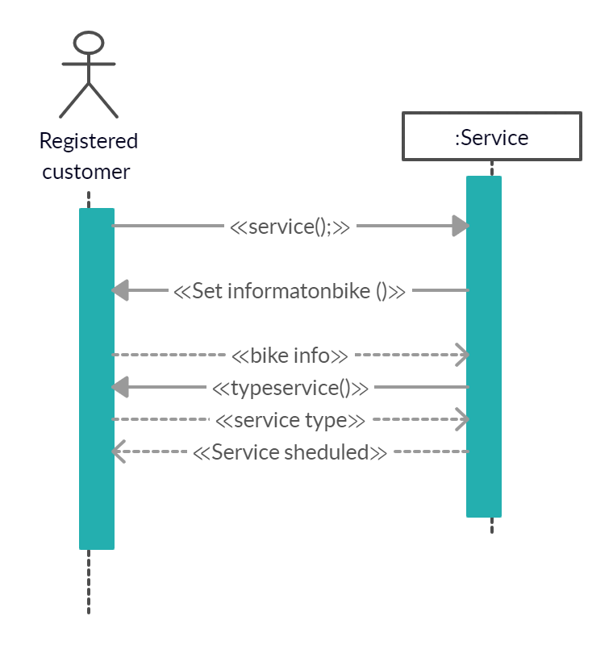

Set time and Date UC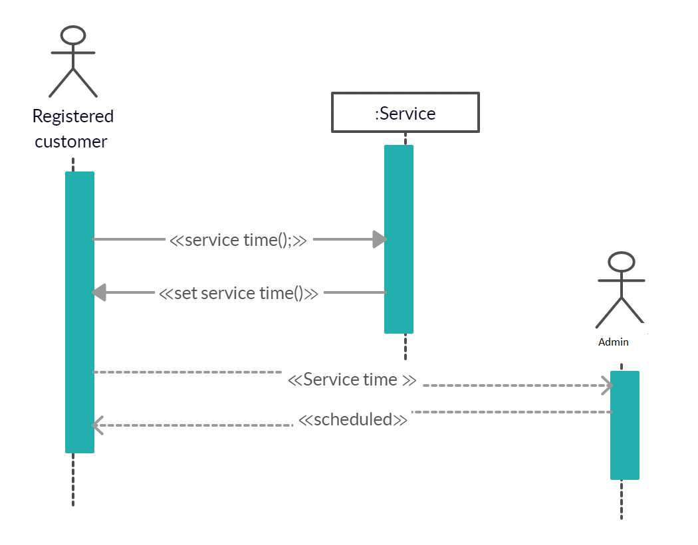

View/update shopping cart

11-i) we depends on Actor class and use-case class Strategies As the message will send to the software object crossponding to real world actor as in login use case, set time for service UC and set tax use case, and use-case class as we define a new class for each use case

Advantages of Actor class:

1. It has clear structure than one central class

Disadvantages of actor class

1. Traceability is more difficult than one central class
2. Limitation reusability
3. There is a further complication when there are two actors that can initiate an interaction

Advantage of use case class

1. Overcome the reuse limitation of actor class
2. Using use case object let you change or replace software to implement a given scenario so as to minimize the effects upon the core concepts
3. Use case object provides traceability from each use cases to class so each use case can understand in isolation

Disadvantages od use case class

1. Large number of extra class must be defined
2. Many of use case classes can be very similar, resulting in duplicated code and more difficult maintenance